**System Profile Parameters**

*To avoid hiding any parameters in the code (or hardcoding) user controlled and managed system profile variable need to be introduced. System Profile Table therefore is designed with UI to end user.*

***System Profile Table***

|  |  |
| --- | --- |
| *System Profile* | |
| *Break_Start* | *Time* |
| *Break End* | *Time* |
| *Break Duration (calculated)* | *Int (float*?) ***(1)*** |
| *Activity Default Start* | *time* |
| *Activity Default End* | *time* |
| *Activity Default Duration* | *8 –* ***calculated by the system*** |

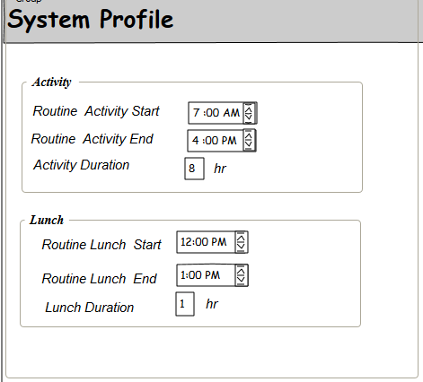

*Default Activity Start and End Times and Duration*

Majority of activities are day long activities and make up a “cycle” that last few days. Typical workday starts at 7am and end at 4pm. This is so called “Routine” Activity.

To alleviate the process of scheduling and entering the initial and final times for each “Routine “activity and each individual assigned to the activity default parameters to be introduced:

Routine Activity Start Time - be stored in System Profile table

Routine Activity End Time - be stored in System Profile table

*Suggested: Add Boolean “Regular” field to Activity Table. Once set to “TRUE”, activity is created with Default Start and End times. By unchecking “Regular” box user will have to enter both activity start and activity end, so the system can calculate exact activity duration*

Introduce “Routine” field, as Boolean, in Activities Table for any such activity. System sets this value to TRUE by default.

If Activity is set as “Routine”, there is no need to enter start and end times. They will be populated from the System Profile values.



*User should be able to re-set (override) initial and end times if activity to be scheduled differently:*

If Activity is not “Routine”, User should unchecks the box. System will dynamically loads “Start” and “End” time fields, and calculates duration once user entered the values (***Start and End become Required fields). System should validate that these fields are entered if “Routine” check box is unmarked.***

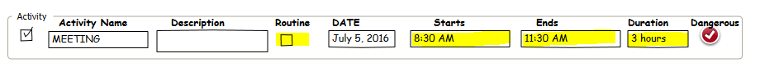

*Lunch Break Times and Duration*

As Part of Administration, create new system variables to control start and end of lunch break and its duration.

Default Break Start Time - be stored in System Profile table

Default Break End Time - be stored in System Profile table

User (administrator) should be able to set Lunch Break “From” and “To“ times.

*Irregular Activity Times*

System should validate that activity Start time or end time doesn’t happen during Lunch:

Following conditions should be confirmed:

1. Start Time < 12 pm or Start > 1pm

2. End Time < 12 pm or End Time > 1pm

3. Start Time < End Time

*Calculating Activity Duration*

If activity is not a Routine activity then exact activity duration should be calculated :

*System will deduct break from time of activity if it happens to begin before and end after lunch.*

***[****(Activity End* ***–*** *Activity Start)* ***–*** *(Break End* ***–*** *Break Start)****]***